1. 測試內容:

測試Flow之match field: “IP_DSCP”是否正確運行

1. 測試環境架構:

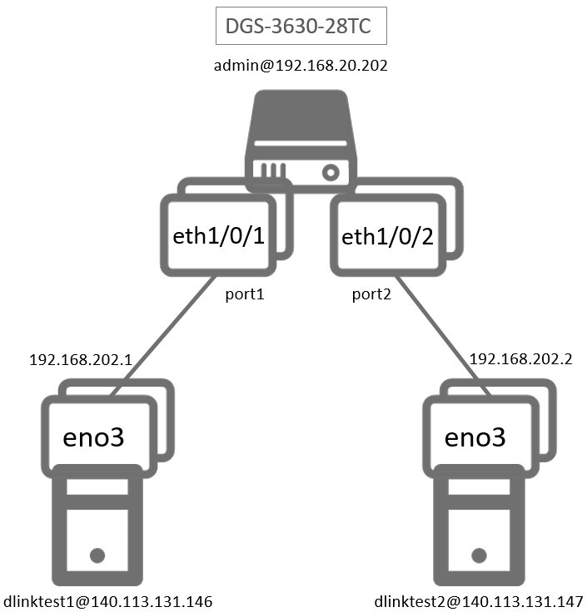

1. 測試環境組態

* SDN controller: ONOS 1.15.0
* Switch: DGS-3630
* Hosts:
* ubuntu 16.04.5 LTS
* dlinktest1(實體機)
  + - IP : 192.168.202.1
    - MAC : d0:94:66:5d:5e:08
    - Port : 1
* dlinktest2(實體機)
  + - IP : 192.168.202.2
    - MAC : d0:94:66:5c:45:20
    - Port : 2
* Apps:

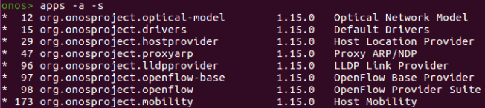

1. 使用之JSON文件

* Flow rule: ”ETH_TYPE”為必要前置 (附檔: flow_ip_dscp.json)

|  |
| --- |
| {  "flows":  [  {  "priority":40001,  "timeout":0,  "isPermanent":true,  "deviceId":"of:000078321bdf4000",  "treatment":{  "instructions":[  {  "type":"OUTPUT",  "port":"2"  }  ]  },  "selector":{  "criteria":[  {  "type":"ETH_TYPE",  "ethType":"0x0800"  },  {  "type":"IP_DSCP",  "ipDscp":46  }  ]  }  },  {  "priority":40002,  "timeout":0,  "isPermanent":true,  "deviceId":"of:000078321bdf4000",  "treatment":{  "instructions":[  {  "type":"OUTPUT",  "port":"1"  }  ]  },  "selector":{  "criteria":[  {  "type":"IN_PORT",  "port":"2"  }  ]  }  }  ]  } |

1. 測試步驟
2. ONOS GUI: Flow View

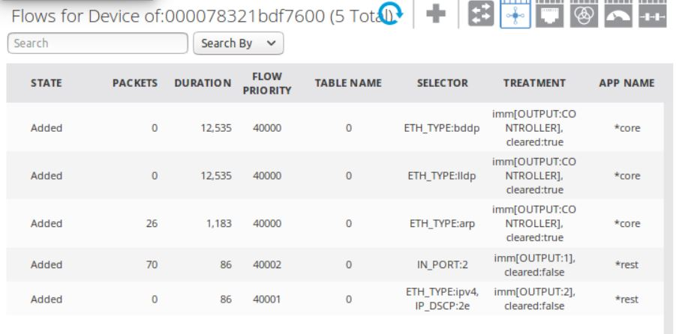

1. Monitor: Using ping tool

* Let dlinktest1 ping dlinktest2

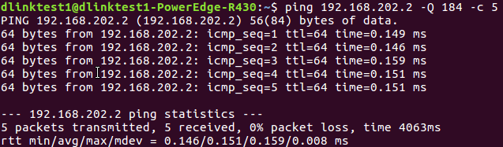

* dlinktest2 uses tcpdump to monitor

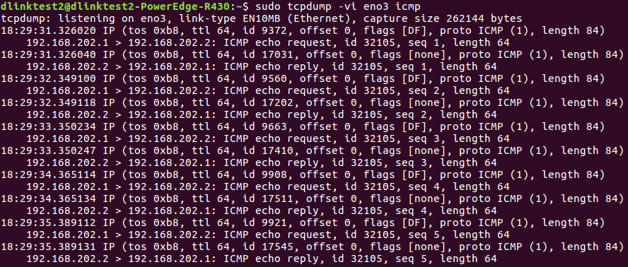

tos = 0xb8 = (1011 1000)2 → dscp = (10 1110)2 = (46)10

1. 測試結果

Flow之match field: “IP_DSCP”正常運行